**King Fahd University of Petroleum & Minerals**

Information and Computer Science Department  
**SWE 316: Software Design and Construction (Term 222)**

Homework # 1 Weight 6%

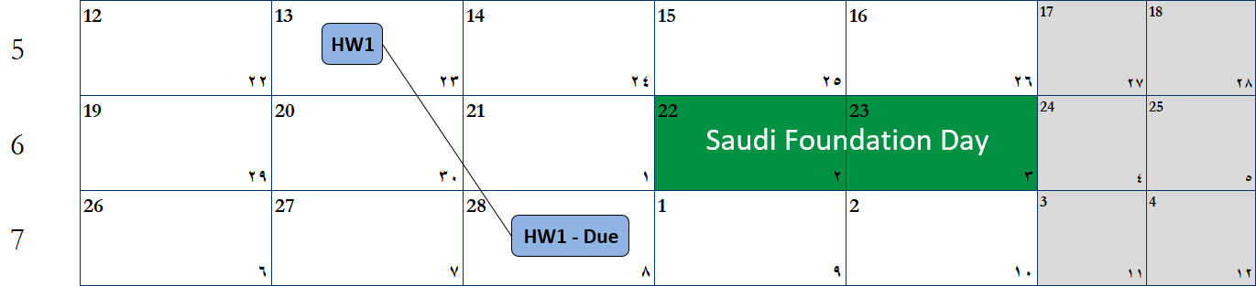

# Instructions

1. Answers have to be typed; **handwritten solutions will not be accepted**.
2. Submission:
   1. through BlackBoard
   2. **Softcopy** - report in PDF  format (**WORD format is NOT acceptable**).
   3. **Source code** should be submitted as a single compressed file
3. The report should include a **cover page** showing: course name, assignment number, date of submission, your names and ID’s
4. Include the following table in your cover page

|  |  |  |  |
| --- | --- | --- | --- |
| **Task** | **Grade** | **Your Grade** | **Comments** |
| Task # 1: Class Diagram | 20 |  |  |
| Task # 2: Application | 40 |  |  |
|  |  |  |  |
| Check list and penalties  No Cover page with grade table -10 🞎  File name (report) -5 🞎  Not in PDF format -10 🞎 | | | |
| Total | 60 |  |  |

1. Include the question text and then put your answer
2. The file (report) name should be in the following format: **HW<#> - <YOUR ID> - <YOUR NAME>**
3. Your report **MUST** include your code and it should be formatted properly
   1. Copy the code in Notepad++
   2. Code should be in **“Courier New”** font
   3. To format the code choose Menu 🡪 Language 🡪<your selected language>
   4. Click Plugins 🡪 NppExport 🡪Copy RTF to clipboard
   5. Paste it in Word

Try to use some callouts (like this one) to illustrate the code

* 1. NOTE: You don’t have to copy ALL your code.   
     Just copy the parts that need to be illustrated.   
     e.g, GUI code is not needed

1. Correct solutions earn full mark. However, ***not following the previous points will reduce your mark.***

# Problem Description Introduction

The Talent Acquisition (TA) team department at xyzSoft is responsible for hiring needed staff members for the company. Every month, they go through hundreds of resumes (CV’s) to evaluate candidates to shortlist them for interviews. This takes a lot of time and effort from the TA team and affects hiring time for departments who need certain positions urgently. Luckily, they found an online service that has the ability to parse these resumes and outputs the result in the format of JSON files ([www.json.org](http://www.json.org)). You are required to write a program that has the ability to parse these JSON files and convert them to proper objects and then visualize them.

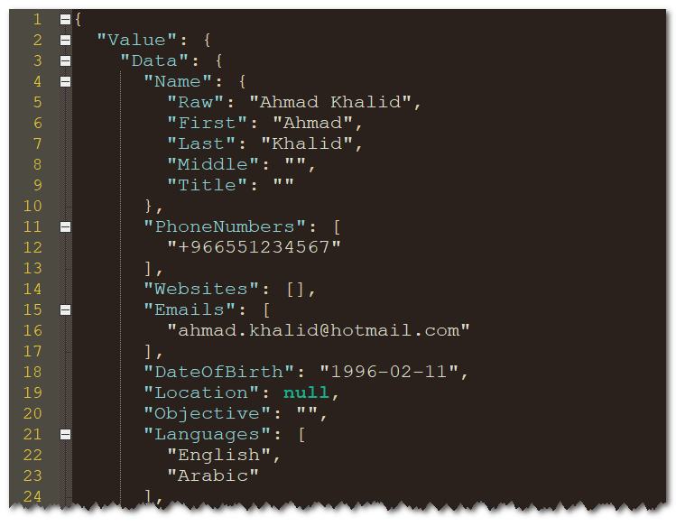

Figure : Sample JSON file

## What is required?

You are required to go through the sample JSON files and:

1. Understand the structure of the resumes.
2. Design a proper class diagram.
3. Develop a program that implements can visualize these JSON files (details are shown below)

## Programming Language?

There is no restriction on the language that you use for this homework as long it is an OO language. I strongly recommend going with Visual Studio using either C# or VB.NET.

# Task 1: Initial Class Diagram

The structure of JSON file is complex and has to be reflected in a proper way in your program. Develop a class diagram that reflects this structure and make sure to follow the main principles we discussed in the class including:

* Abstraction and Encapsulation
* Single Responsibility Principle
* Open-Closed Principle

You have to include all fields and methods in every class with proper access modifiers (private, public, etc.). If the relation between two classes is an association, specify the multiplicity, label and direction of the relationship. Make sure that your class diagram represents all needed components in this system.

# Task 2: Develop the application

Develop your program to fulfill the following requirements:

1. When executed, it should parse a single folder that contains the list of JSON files
2. The list of JSON files should be presented in the program in a listbox
   1. The list should show the name of the candidate (not the JSON file name)
3. When you click one of the resumes in the list, you should visualize the resume by presenting its data according to the following picture (This is only a sketch and you are welcome to enhance it according to your understanding of this domain)

NOTE: Your program should reflect your class diagram

<<<<<<<<<<<<<<<<<<<<<<<<<<<<<< END >>>>>>>>>>>>>>>>>>>>>>>>>>>>>>